
Market Research Final Delivery
Maximilian Nott, Michal Kosnik Moritz Arndt, Aleksandar Nemski and Miguel Angel Vich

November 20, 2024
University of Navarra

Contents
1. Quantitative Survey Results 2
2. Details of Fieldwork 2
2.1 Space 2
2.2 Time 2
2.3 Problems Encountered 3
2 Data Analysis 3
3 General Report 15
4 References 18
5 Appendix 18

Quantitative Survey Results
Overall, the survey was successful with 55 participants responding to questions regarding BODR Electric-Escooters in Pamplona with results in the appendix.

Details of Fieldwork

Space
Spacing was an important consideration with the creation of the survey as having appropriate designs in a survey impacts quality of responses gathered as respondents can easily understand questions and the survey itself (Ball, 2019). The fonts, colour scheme and layout of the survey was considered hence the justification for the usage of google forms was used due to the simplicity of the layout and the easy conversion to excel data to assist with completing part c. of brief 4. Furthermore, the usage of google forms allows for a URL link to be generated allowing for accessibility for participants. The data collection methodology to prove/disprove the hypothesis involves random sampling using a Google Forms survey to gather data associated with the two main variables of electric scooter affordability and accessibility. To gather participants, the survey will be spread through a URL link to individuals who go to university such as group chats with students and individuals who study within Pamplona.

Time
The timing was an important factor when the survey was sent to group chats as well as to people who survived in the field. Certain factors such as when people were surveyed influence the overall quality of responses an example involves asking for someone to complete a survey late at night where individuals will not be as engaged as someone during the middle of the day (Estelami, 2014). The survey was constructed with the consideration of allowing participants to complete the survey in a reasonable time without the participant getting disengaged due to a lengthy survey. This consideration resulted in the survey having 14 questions to keep respondents engaged (Estelami, 2014). Regarding the posting of the survey in group chats and participants, the timing was an important factor in when the survey was sent oftentimes, consisting during the middle of the day to ensure that the largest group of individuals would view the survey. Additionally, Furthermore, there were cases (<7 Individuals) where data was sourced in the field before and after class without sending a URL to a group chat. This may have created potential biases and timing and space issues regarding the sourcing of data as respondents may not have been as focused on the survey but instead on the upcoming class or tired after class.

Problems Encountered
Throughout the data-gathering process, certain problems were encountered throughout the data collection process that impacted the overall quality of the data gathered. The first problem encountered involves the majority (>25 Individuals) of willing participants consisting of individuals from one residence close to the campus resulting in sampling bias despite the data gathering method being random sampling. Due to the limitations of using random sampling through online questionnaires, the validity of certain responses may be inaccurate or misleading resulting in doubts about the accuracy of certain respondents. This can be observed with questions such as Question 2 (How do you usually commute to university or around the city?) where respondents entered false options in the ‘other’ question such as horse riding, teleportation and metro. These individuals will be removed from the data cleansing process on the assumption that due to their responses in Question 2, they did not take the remainder of the survey seriously to preserve the integrity of the data.

Data Analysis
Question 1
Are you interested in participating in a survey assisting a small company and their market entry into Pamplona?
Yes
Frequency: 48 Percentage: 78%
No
Frequency: 7 Percentage: 22%
Conclusion:
With 87% of respondents stating that they were interested in the survey, the responses obtained can be considered representative of the research purpose.
Question 2
How do you usually commute to university or around the city?
Walk
Frequency: 39 Percentage: 71%
Bus
Frequency: 9 Percentage: 16%
Car
Frequency: 3 Percentage: 5%
Cycling
Frequency: 1 Percentage: 2%
Other
Frequency: 3 Percentage: 6%
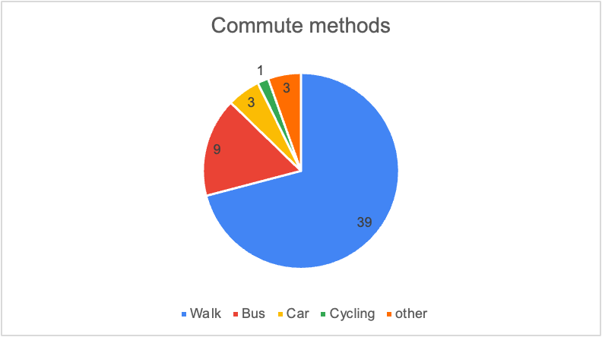
Conclusion:
As most of the respondents of the survey said their usual way of transporting is walking (71%), this means that answers can be usable for our research
Question 3
Distance from University when walking?
<10 minutes
Frequency: 15 Percentage: 27%
10-20 minutes
Frequency: 19 Percentage: 35%
20-30 minutes
Frequency: 14 Percentage: 25%
30-40 minutes
Frequency: 1 Percentage: 2%
+40 minutes
Frequency: 6 Percentage: 11%
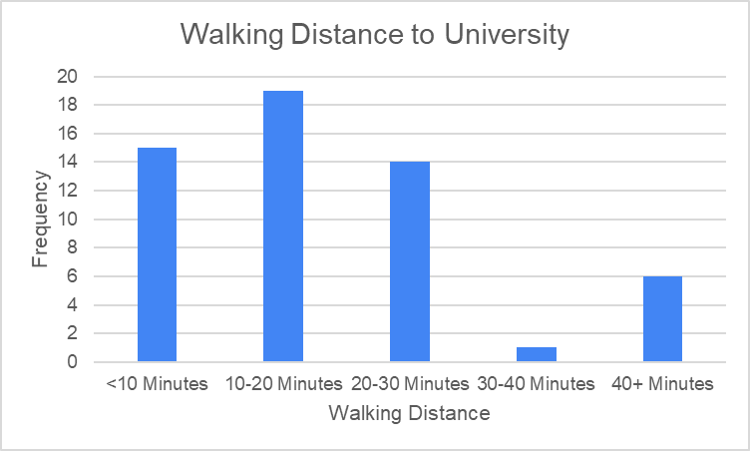
Conclusion:
62% of respondents need 20 minutes or less for their daily commute to university. For them, it is within easy reach to walk. However, around 38% of respondents need more than 20 minutes to get to university. For this group, an alternative to walking would probably make a lot of sense.
Question 4
Have you considered using alternative transportation methods (e.g., electric scooters) in the past year?
Yes
Frequency: 25
No
Frequency: 22
Maybe
Frequency: 8
Conclusion:
Nearly half of the respondents have considered using an alternative transportation method (25 people), which leads to the conclusion that our idea of electric scooters is applicable.
Question 5
On a scale of 1-5, how would you rate Pamplona's public transport and infrastructure for non-car modes of transportation (e.g., bike lanes, docking stations)?
1
Frequency: 1 Percentage: 2%
2
Frequency: 5 Percentage: 9%
3
Frequency: 15 Percentage: 27%
4
Frequency: 23 Percentage: 42%
5
Frequency: 11 Percentage: 20%
Average: 3.69 Median: 4 Mode: 4
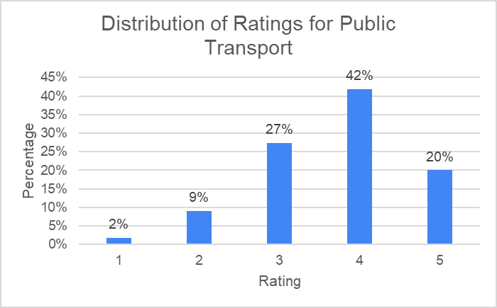
Conclusion:
The respondents tended to rate the local public transport system as good. The calculated average rating was 3.69 with a median and mode of 4. 42% rated it as 4 and 20% even gave it the best score of 5, which suggests that the majority are satisfied with it. However, around 11% rated it as 1 or 2. This large difference in rating and the considerable dissatisfaction of this group of respondents shows that there is still plenty of room for improvement.
Question 6
On a scale of 1-5, how would you rate Pamplona’s infrastructure for electric scooters specifically (bike lanes, roads, charging stations)?
1
Frequency: 2 Percentage: 4%
2
Frequency:3 Percentage: 5%
3
Frequency: 19 Percentage: 35%
4
Frequency: 25 Percentage: 45%
5
Frequency: 6 Percentage: 11%
Average: 3.55 Median: 4 Mode: 4
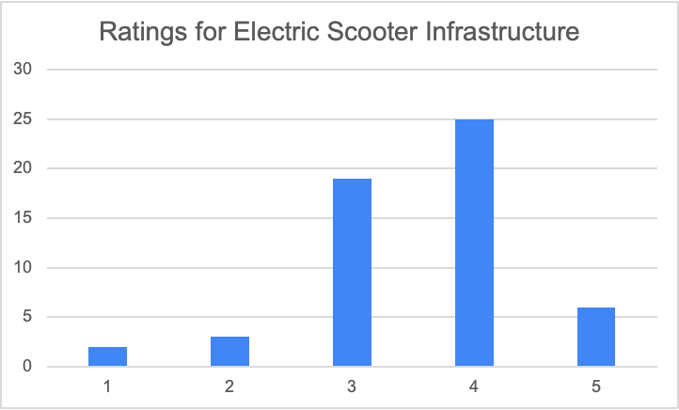
Conclusion:
Based on the average and the median of our respondents we can conclude that our survey responses are suitable for our idea for electric scooters
Question 7
How would you describe your current financial situation as a student in Pamplona?
1
Frequency: 3 Percentage: 5%
2
Frequency: 9 Percentage: 16%
3
Frequency: 23 Percentage: 42%
4
Frequency: 16 Percentage: 29%
5
Frequency: 4 Percentage: 7%
Average: 3,16 Median: 3 Mode: 3
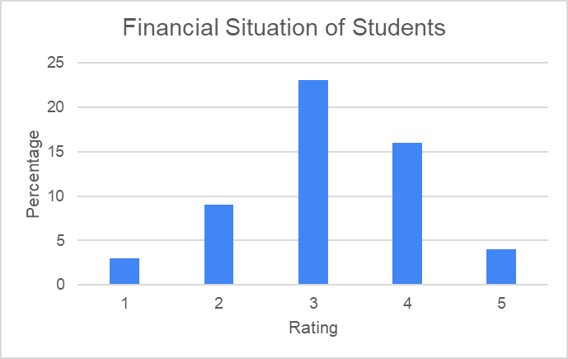
Conclusion:
The answers of the respondents show that, with an average of 3.16, most of them assess their financial situation quite moderately. However, around 21% of respondents only rated their financial situation as 1 or 2. Only 7% gave the highest score of 5. Pricing to the target group we surveyed is therefore extremely important.
Question 8
How important are sustainability and environmental impact in your choice of transportation?
1
Frequency: 6 Percentage: 11%
2
Frequency: 9 Percentage: 16%
3
Frequency: 17 Percentage: 31%
4
Frequency: 19 Percentage: 24%
5
Frequency: 10 Percentage: 18%
Average: 3.22 Median: 3 Mode: 3
Conclusion:
From the results we can interpret that more than half our respondents think that sustainability is crucial in terms of transportation, which connects with our idea of transport in Pamplona
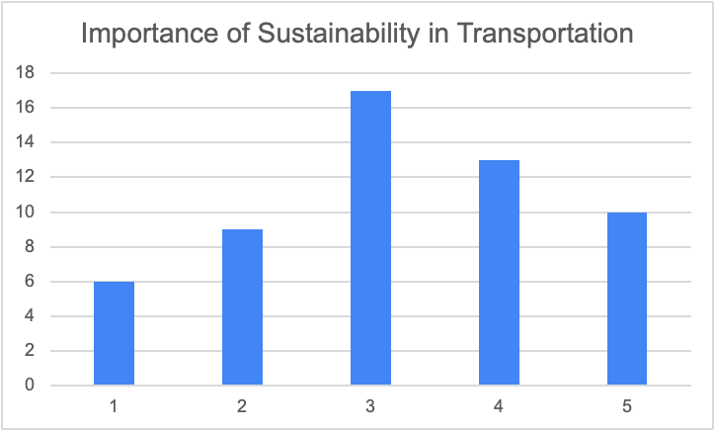
Question 9
Would you consider purchasing an electric scooter?
Yes
Frequency: 17 Percentage: 31%
No
Frequency: 38 Percentage: 69%
Conclusion:
Only 31% percent of the respondents are interested in purchasing an electric scooter. The majority (69%) are not interested. This indicates that there is only a limited demand for the product which does not support our research question.
Question 10
If Yes, what factors would influence your decision?
(Selected No to Prior Question):
Frequency: 20 Percentage: 36%
Convenience:
Frequency: 9 Percentage: 16%
Environmental Impact:
Frequency: 6 Percentage: 11%
Price:
Frequency: 17 Percentage: 31%
Accessibility:
Frequency: 2 Percentage: 4%
Other:
Frequency: 1 Percentage: 2%
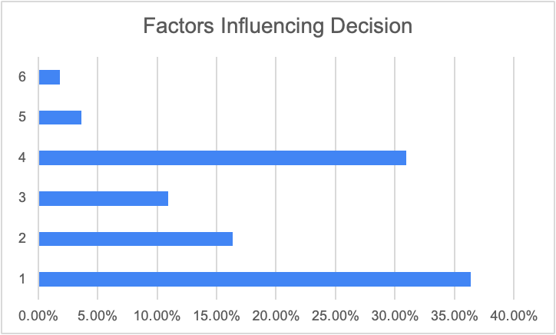
Conclusion:
Based on the respondents' answer we can conclude that the price is the most important factor (31%) in terms of purchasing a scooter.
Question 11
What are the main barriers (if any) that prevent you from considering an electric scooter for commuting?
Already satisfied with current commute
Frequency: 19 Percentage: 35%
Safety concerns:
Frequency: 2 Percentage: 4%
Lack of infrastructure:
Frequency: 11 Percentage: 20%
Cost:
Frequency: 23 Percentage: 42%
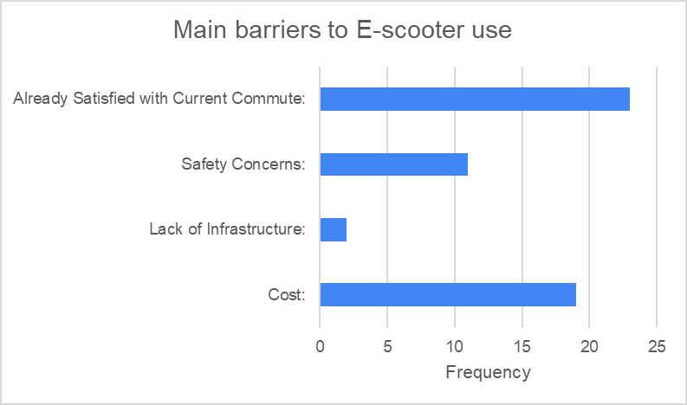
Conclusion:
Cost is the biggest concern, with 42% of respondents citing it, indicating that an affordable pricing strategy is essential. Additionally, 35% are satisfied with their current commute, suggesting a limited willingness to switch unless clear benefits like flexibility or speed are emphasized. Infrastructure limitations (20%) are a moderate challenge, while safety concerns (4%) are minimal.
Question 12
If you don't already use one, would you get to university faster if you traveled by E-scooter instead of your current mode of transport?
Yes
Frequency: 43 Percentage: 78%
No
Frequency: 12 Percentage: 22%
Conclusion:
Almost all of our respondents (43 people) have agreed that using an electric scooter is faster than using their usual way of transport, which supports our idea and the purpose of this survey.
Question 13
What is the maximum you would spend on an E-scooter, if given the opportunity?
€100-200
Frequency: 26 Percentage: 47%
€200-300
Frequency: 29 Percentage: 35%
€300-400
Frequency: 5 Percentage: 9%
+€500
Frequency: 2 Percentage: 4%
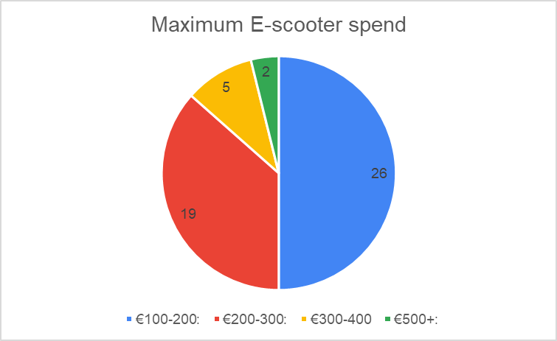
Conclusion:
Price (243.99€) is within the budget of 35% of respondents. It may be possible to gain a larger customer base through discount campaigns or slightly lower prices (possible through process optimization or material.
Question 14
If you don’t already have one, what is stopping you from using an E-scooter? Tick all that apply. If other, please use the space below to describe in one or a few words/phrases:
Price (too expensive)
Frequency: 37 Percentage: 67%
Distance (too far to travel with an E-scooter)
Frequency: 6 Percentage: 11%
Safety
Frequency: 16 Percentage: 29%
Not sure where to buy
Frequency: 20 Percentage: 36%
Lack of appropriate infrastructure (roads, storage, parking etc)
Frequency: 12 Percentage: 22%
Other
Frequency: 7 Percentage: 13%
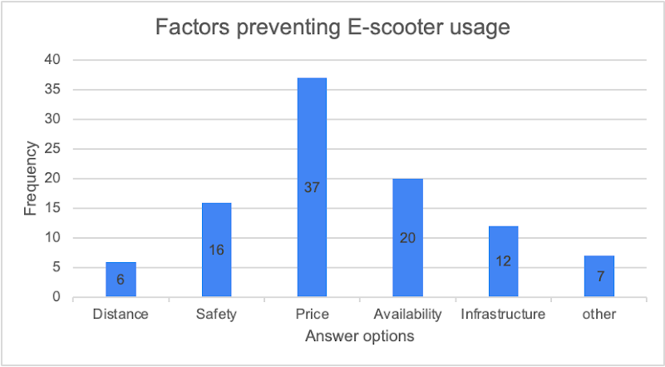
Conclusion:
67% (37 individuals) of the respondents chose price as a primary barrier for the purchase of an e-scooter. However, with the estimated average price (243.99) of one of our previous questions (question 13), we think that we can decrease that barrier for E-scooter usage, which in fact will increase the utilization of electric scooters.

General Report
As urban landscapes evolve and sustainability takes center stage, electric scooters (e-scooters) are emerging as a modern solution to the challenges of urban transportation. This report examines the feasibility of introducing BODR e-scooters to Pamplona, focusing on the city’s large university student population. With its compact size, young demographic, and increasing focus on sustainable transport, Pamplona presents a promising market for BODR’s entry. However, understanding the commuting habits, perceptions, and potential barriers faced by students is essential to develop a tailored strategy that ensures success.
The research process began by defining the core objective: assessing whether university students in Pamplona would adopt e-scooters as an alternative mode of transport. To address this question, the study aimed to understand students’ commuting preferences, their attitudes toward e-scooters, and the barriers they perceive to adoption. The methodology employed a combination of quantitative and qualitative approaches, ensuring a comprehensive understanding of the target market.
The primary method of data collection was a survey distributed both online and in person to students at the University of Navarra. With over 70 respondents, the survey explored topics such as current commuting habits, infrastructure perceptions, financial considerations, and openness to adopting e-scooters. Complementing this data were five focus groups, which provided qualitative insights into student attitudes, including discussions on safety, affordability, and the practicality of using e-scooters in Pamplona. Finally, secondary data from industry reports and demographic studies added depth to the analysis, allowing the findings to be placed in a broader market context.
Once collected, the data underwent a meticulous cleaning process to ensure reliability. Frivolous or unrealistic responses, such as “teleportation” as a commuting method, were excluded from the analysis. The cleaned dataset was categorized, highlighting trends and recurring themes, while focus group discussions were transcribed and thematically coded. This systematic approach ensured that the findings were robust and actionable.
The results of the study revealed valuable insights into the commuting behaviors and preferences of university students in Pamplona. Walking emerged as the dominant mode of transportation, with approximately 70% of respondents identifying it as their primary method of commuting. This was largely attributed to proximity, as many students live within a 10-20 minute radius of the university. For those living farther away, buses were the next most popular choice, followed by cycling. E-scooters were rarely used, with most respondents citing limited access and high costs as deterrents. These findings suggest that while walking and buses currently dominate, e-scooters have the potential to fill a gap for students with longer or less convenient commutes.
When asked about Pamplona’s infrastructure, students provided mixed reviews. Public transport infrastructure received an average rating of 3.8 out of 5, with many respondents appreciating the availability of bike lanes and frequent bus services. However, a lack of docking and storage facilities for shared mobility options was noted as a significant limitation. In contrast, infrastructure for e-scooters received a slightly lower score of 3.4 out of 5. Students highlighted issues such as insufficient parking spaces, limited charging points, and difficulties navigating older parts of the city. These results indicate that while Pamplona has a solid foundation for e-scooter use, targeted improvements in infrastructure could significantly enhance their viability.
Financial considerations emerged as a major barrier to adoption. On average, respondents rated their financial situation at 3.2 out of 5, reflecting moderate affordability. When asked about their willingness to pay for an e-scooter, over 50% of respondents preferred a price range of €100-200, while only a small proportion were willing to spend over €300. This sensitivity to price underscores the importance of affordability in influencing adoption. To address this, BODR could consider offering entry-level e-scooters within the €150-200 range or introducing flexible payment plans. Additionally, a digital renting system, like shared e-bike platforms, could be highly effective. A proposed rental fee of €2 per hour, or €25 for unlimited monthly use, would provide an accessible option for students, particularly those hesitant to commit to an outright purchase.
Despite these challenges, there is clear interest in e-scooters among students. Approximately 40% of respondents expressed a willingness to consider purchasing an e-scooter, with convenience and time savings cited as the primary motivators. However, safety concerns and the lack of adequate infrastructure were frequently mentioned as barriers. Sustainability, while appreciated as a secondary benefit, was not a primary driver for most students. Instead, practicality and affordability took precedence.
The findings align with the study’s objectives and provide valuable insights into the potential for BODR e-scooters in Pamplona. However, the research also highlighted several limitations. The sample was skewed toward students living near the university, potentially underrepresenting those with longer commutes. Additionally, the study focused exclusively on Pamplona, limiting its generalizability to other regions. Finally, the short duration of the study constrained the depth of data collection, and the sustainability-related questions could have been more detailed.
Looking ahead, future research should address these limitations. Expanding the geographic scope to include other cities with similar demographics would provide comparative insights. Conducting longitudinal studies could track the evolution of commuting behaviours and e-scooter adoption over time. Moreover, a pilot program in Pamplona, offering both purchase and rental options, would provide valuable real-world data on adoption barriers and motivators.
Based on the findings, several recommendations can be made. BODR should focus on affordability by offering budget-friendly e-scooters and introducing a digital rental system. Collaborating with local authorities to improve docking, parking, and charging infrastructure would address key barriers. Safety campaigns, including workshops and instructional materials, could build user confidence. Marketing efforts should emphasize the convenience and time savings of e-scooters for long-distance commuters while positioning sustainability as a complementary benefit. Finally, a pilot program would allow BODR to test its strategy, refine its offerings, and build awareness within the student community.
In conclusion, this study demonstrates significant potential for BODR e-scooters to meet the commuting needs of university students in Pamplona. While challenges such as affordability and infrastructure limitations exist, these can be effectively addressed through targeted strategies. By offering flexible pricing models, leveraging a digital renting platform, and working with local stakeholders, BODR can successfully position itself as a leader in sustainable urban mobility. With thoughtful planning and ongoing research, BODR has the opportunity to make a meaningful impact in Pamplona’s transportation landscape.

References
Ball, H. L. (2019). Conducting online surveys. Journal of Human Lactation, 35(3), 413–417. Sage Journals. https://doi.org/10.1177/0890334419848734
Estelami, H. (2014). The Effects of Survey Timing on Student Evaluation of Teaching Measures Obtained Using Online Surveys. Journal of Marketing Education, 37(1), 54–64. https://doi.org/10.1177/0273475314552324

Appendix
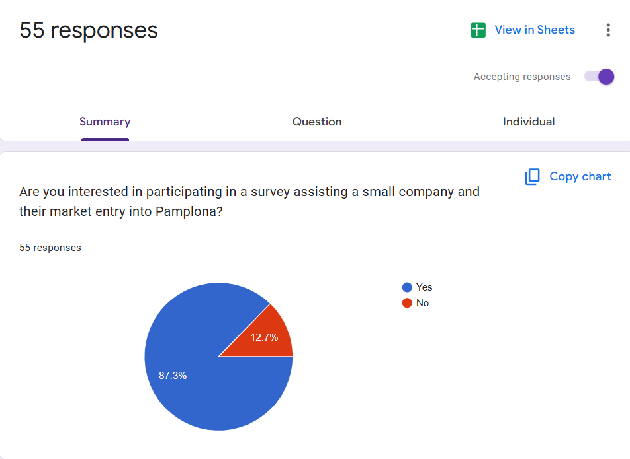Figure 1: Survey Results
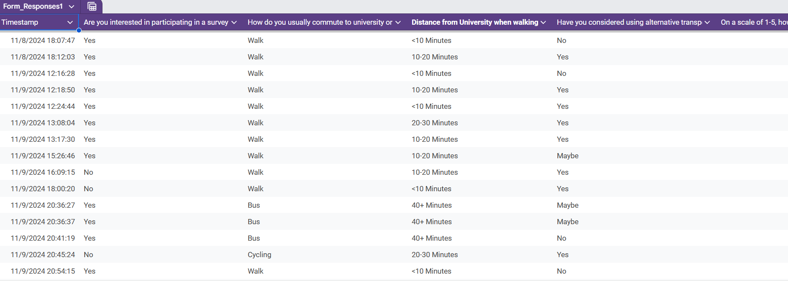
Figure 2: Google forms data

